Introduction:
Welcome to Berlin Activities Depot Summer Camp
Program 2020!
We are excited that you have chosen Berlin Activities Depot for your summer fun and we look forward to working with you! This is our registration packet, please take the time to accurately answer each question and fill in each blank carefully as this information is critical for B.A.D to effectively care for your child this summer. Berlin Activities Depot summer camp starts the second Worcester public schools are out of school and concludes the day before the children go back to school.

Camp Overview:

AGE
We accept children ages ranging from 5 to 15 years. (Must be 5 years old to attend weekly field trips)

LUNCHES, SNACKS, & PLENTY OF FLUIDS
This year we will be providing breakfast, lunch and snacks for each camper. (Must fill out food program application and enrollment form). There is no access to a microwave or refrigerator for summer camp, so please pack accordingly, if you would prefer your child to pack. It is very important that all campers have plenty of fluids throughout the day as our camp is very active. Water and sports drinks are recommended and are the responsibility of the parent. Extra snacks and drinks can be bought at our facility, if you would like your child to purchase additional items, please either fill out the credit card authorization for them to purchase or put money on a gift card for them. Please label any snacks or drinks brought from home with a permanent marker! Our facility has water fountains that are accessible to the children during their active classes.
FIELD TRIP
On field trip mornings you can turn money into the front desk to be labeled and held by the summer camp counselors for your child to use during field trips. These funds are different from grub hub gift cards. Money left with children is not safe and if lost it is not covered by B.A.D.

SUN BLOCK
Children need to come with sun block applied prior to sign in; all children must provide their own, labeled,
sun block.

CAMP T-SHIRT
The camp t-shirt must be worn to every single field trip outside our facility without exception! Parent’s please purchase additional shirts if needed, they are only $15.00. If you do not send your camper in their shirt on a trip they have paid for, one will be given to your child and billed to your credit card on file.

As questions arise please do not hesitate to ask! Our Camp is filled with activities, games, and fun.
Don’t be surprised if you have some very tired campers at night! Thank you in advance!

Summer Camp Pricing
Weekly Camp Pricing
5 Days  Extended times are available at additional cost | $185
3 Days  Extended times are available at additional cost | $145
Drop-In | $60

Enrollment Pricing (One-time fee)
Early Bird by March 1st | Free
March 2nd—May 1st | $50
After May 1st | $100

Securing Camp Spot:
In order to secure your child’s spot in camp, a $20 non-refundable deposit must be made for each week that your child is attending. This deposit will go towards your total due for that week of camp. (i.e. If your child attends 5 weeks, they must pay $20 per week, meaning $100 will be due upon enrollment. Enrollment Fee total is based upon last deposit payment

Tuition
The remaining tuition is due every Friday prior to the start of the next camp week, No child will be permitted to attend camp without their tuition being paid in full for that particular week. There will be NO EXCEPTIONS!

Late Charge Time & Fees
All credit cards on file will be charged for tuition Monday’s after 5:00 p.m. that are not paid. In the event the
credit card on file is unable to be charged- a late fee of $15.00 will be added if your tuition and your child will be unable to attend until weekly tuition is paid in full. A fee of $35 will be charged for any returned checks/ declined credit card

Tuition Contract
Once you have signed your tuition agreement you will be responsible for paying the balance of said contract whether your child attends camp or not, even if your child drops out at any time for any reason. Children will not go on any field trip without tuition being paid.

Summary:
⇒ $20 Deposit to hold child’s spot for committed weeks
⇒ Tuition is due Friday prior to the start of camp week
⇒ Tuition balance will be charged through credit card on file on Monday’s if not paid
⇒ $35 returned check fee or declined credit card
⇒ A card on file is required and camp tuition is due Friday by 5pm, if do not have an alternate method of payment the card on file will be charged, late fees and decline fees will apply. If not paid your child can not attend the next day if payment did not go through!
Berlin Activities Depot accepts cash, checks, Visa, MasterCard, and Weekly Auto Pay

All students must have a credit card authorization form on file even if paying with another form of payment.

- LUNCHES
Daily Instructions

Lunch can be provided by B.A.D through our food program or items a la carte if you grant your child a gift card or allow them to charge card on file for snacks/drinks. (If you wish for us to provide our meals and snacks per CACFP-please fill out our food program and enrollment form). If you wish to pack lunch: As per the state regulations, camper’s lunches should not contain any perishable food items. There will NOT be a refrigerator or micro wave available at the facility. Parent/Guardians must sign a lunch waiver stating that if any potentially hazardous foods are provided to a camper by the parent/guardian that they will provide a cold pack for their child’s lunch. B.A.D is not responsible for ensuring that the temperature of 45 degrees or below is sustained throughout the child’s camp day. It is recommended that lunches are nutritious to give your child lots of energy throughout the camp day. Please label your child’s lunch clearly so no one accidentally gets the wrong lunch. Field Trip days will be packed lunch, on site days will be hot lunches!
*You can purchase a gift card at the front desk

PICK-UP/DROP-OFF
Campers may be dropped off and picked up anytime in between the camp hours of 7:30AM and 5:30PM. During pick-up, parents will need to see a staff member at the front desk to have their child paged out of the activity they are in, please do not go looking for them. It is our job to get your child out to you with their belongings! Your child will need to sign in and sign out every day at the gym desk! So please make sure your child is being brought in by a parent/guardian!
*Extended care 7:00AM-7:45AM is $10 a week
*Extended care 5:15-6:00PM is $15 per week; 6:00 to 6:15 will be $1 for every minute not picked up
⇒ LATE PICK-UP FEE: $10 late pick-up fee & will be automatically added if continue to pick up late.
⇒ PICK-UP AUTHORIZATION: Campers will not be permitted to leave with someone that is not listed on their pick-up authorization sheet. Anyone picking up a camper will need to show identification to the front desk staff. Please be aware of these rules as they are in the best interest of all children attending our camp. Visitors without an entry fob for security reasons will be buzzed in, therefore we must know exactly who will be coming to pick up your camper. B.A.D. must be notified if someone that is not on the list is picking a child up at least 24hours in advance, and will also need to bring valid picture ID such as driver’s license.
- CLOTHING: A gymnastics suit is recommended but not required. Campers should refrain from wearing
loose clothing because it is safety hazard during gymnastics activities, or really tight jeans. No jewelry is allowed because it too is a safety hazard. Any camper with longer hair should always have it tied back for our various activities. All campers should come to camp with a change of clothes, bathing suit, and tennis
shoes; you never know what will happen. Always Dress for a Mess. Bring extra clothes on Fridays!
- CAMP BEHAVIOR: Campers are expected to behave in a positive manner. All campers must treat other campers and camp staff with respect. Campers may be asked to “go to the comfy corner” of an activity or have a “thinking time” away from the group if the director or a camp counselor feels it is necessary to calm down. If problems persist the director will notify the parent/guardian of the problem. In extreme cases, a camper may be terminated from summer camp without a refund and will be expected to pay the full contracted price. Any questions concerning your child’s behavior may be discussed with the camp
director privately. B.A.D reserves the rights to send children home daily if we feel they are a threat to the other students, themselves, or the instructors. Campers are not permitted to use cell phones/tablets at camp.

Field Trips

Every week Berlin Activities Depot Summer Camp will be embarking on field trips. Our younger campers will generally go on Tuesdays or Thursdays and our older campers will go on Mondays or Wednesdays. The campers must be in attendance by 830am sharp to be ready for the trip, they will return promptly by 5:15pm for pick up. We will have additional offsite learning experiences and field trips throughout the summer and will be sure to let you know when we embark on additional adventures.

- Campers will not be permitted to go on any field trips without their weekly tuition being paid first. No camper will be permitted to attend a field trip without a signed permission slip included in the registration packet.
- All campers going on the trips must be present at B.A.D. by 8:30am or as otherwise specified.
- Campers that choose not to attend will remain at the gym and proceed with a fun camp day filled with activities.
- Each field trip’s instructions and requirements may differ and will be provided to parents/guardian in advance, any changes to our itinerary will be given out that week of camp. If a parent wishes to join their child, they must pay the entry fee for themselves.
- Water park field trips require participants to be 5 years or older to attend without an additional guardian present. In order to attend pool and water park trips campers must be able to swim. The Campers that are under 5 will not be permitted to attend water park field trips.
- After you have paid your activities fee’s/weekly camp fees they are non-refundable even if your child does not attend.
- B.A.D reserves the right, without refund, to refuse any child not exhibiting proper behavior to attend any given field trip.

FUN-FILLED FIELD TRIPS INCLUDE:
Jolly Rogers, Coco’s, Shell We Bounce, Delmar Atmosphere, Crown, Frontier Town, Maui Jack’s, Discovery Center and much, much more!!

Field trip schedule posted at the beginning of the month
If your child is participating in field trips please be sure to fill out all required permission slips found in the packet. If any are unsigned your child will not be able to attend the field trip until we receive a signed copy.

Cell Phones/Electronics
**Campers are not permitted to have or use cell phones or tablets at camp. If lost or stolen BAD is not responsible.If seen, counselors will take their phone and it will be kept at the front office until pick up. Should you need to contact your child during the day feel free to call the office at 410.629.0878**

Sample Daily Schedule

Berlin activities Depot is 30,000 square feet of fun. Additional age groups and rotations created upon summer camp registrations, all groups will be split evenly, age groups 4—5 with no more than 8 students and 6+ no more than 15 students, ratios are usually much less. Every child gets to participate in every activity offered each week, this is a sample, classes may be added, deleted or changed according to children’s preferences and weekly themes and special activities.

Sample daily schedule-This is only an example-A finalized schedule will be out once we are closer to summer!

Time | 5-6 year old girls | 5-6 year old boys | 7-8 year old girls | 7-8 year old boys
7:00-7:45 | Extended Care Drop off in Kidz Zone Trampoline/Pitt Park
7:45-9:00 | Wake up with music, trampolines, and more
9:00-10:00 | Trampoline and Tumbling  Snack 1 9-915 | Gardeners Galore  Snack 1  9—915 | Expressive Dance  Snack 2  945—10:00 | Ninja Warriors  Snack 2  945—10:00
10:00-11:00 | Hip Hop expressive dance | Creation Station | Ninja warrior zone | Open Jump
11:00-11:30 | Lunch | Lunch | Spa time | Dodgeball show down
11:30-12:00 | Mad scientist | I Beam Fun | Lunch | Lunch
12:00-1:00 | Ninja Nation zone | Laser tag | Spa Day | FAST Class
12:30-1:30 | I Beam education interactive game | Trampoline and tumbling | Lights Camera Ac- tion- acting acade- my | Laser tag
1:30-2:30 | Little chefs | Little Chefs | Gymnastics | Parkour
2:30-3:30 | Tech academy | Expressive Dance | Cheer | Trampoline- tumbling
3:30-4:00 | Nerf Gun Wars | Tech academy | Little Chefs | Little Chefs
4:00--415 | Change for activities
415—515pm  combined group activities | Gymnastics, Cheer, Fast class, Ninja nation, Jiu Jitsu, Karate.

FRIDAYS ARE SPECIAL EVENT DAYS FROM COMPETITIONS, TALENT SHOWS, SLIP AND SLIDES AND MORE.

Other Activities

Our Awesome Activities
- Down and Dirty Food Frenzy
- Glow Parties
- Water Gun Wars
- Dodge Ball Showdown
- Mad Scientists
- Lights, Camera, Action!
- Sidewalk Art
- And So Much More!

Facility Amenities
- Trampolines
- In-ground pits
- Laser Tag
- Ninja Warrior Zone
- Tech Academy
- Little Chefs
- Dance
- Big Screen Movies
- And So Much More!

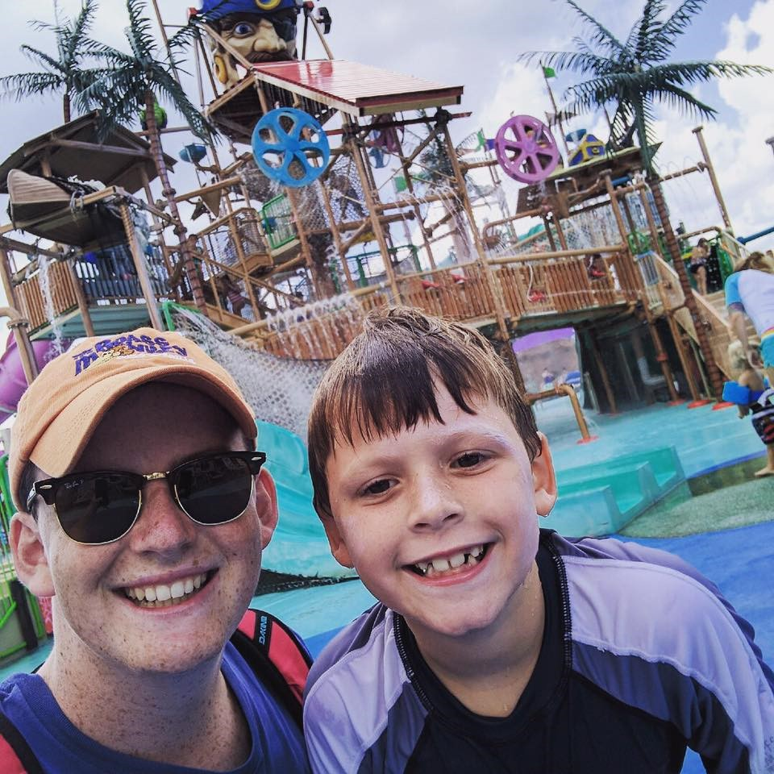

Berlin Activities Summer Camp Form
PARENT Name
Salutation: |  | Parent Last Name:
Parent First Name: |  | Parent Middle Initial:
Parent Personal Information
Parent Date of Birth: |  | Gender:
Marital Status (please circle): Single | Married |  | SPOUSE NAME:
Emergency Contact Information: |  | Emergency Contact Name:
Emergency Contact Mobile: |  | Emergency Contact Home:
Mailing Address
Home Street Address:
City: |  | State: |  | ZIP Code:
Parent telephone (need 2) (please circle best way to contact)
Mobile: Home:  Name: Name: | Business:  Name: |  | Other:  Name:
Parent Email (email you frequently check)
Parent Email:
Billing Address If Different Than Mailing
Street Address:
City: |  | State: |  | ZIP Code:

OFFICE USE ONLY
Start Date of Camp: End Date of Camp:
Total owed for Camp: Total Deposit for Camp: Membership/Registration Fee: Summer Camp Enrollment Fee: Weekly Rate for Camp Weekly Payment Less Deposit/down payment
Date received: Amount received: Payment Type:
Other Comments:

Summer Camp Child 1
Child Name
Salutation: | Child Last Name:
Child First Name: | Child Middle Initial:
Child Personal Information
Child Date of Birth: | Gender:
Child Address (if different than parent)
Home Street Address:
City: | State: | ZIP Code:
Other
What is the race/ethnicity of you/your camper? ( ) Prefer not to say
*Knowing the demographic makeup of our campers/community can assist in grant writing, intentional outreach, and more—please respond if you feel comfortable.
T-Shirt Size (Please Circle One)
Youth: XS SM MED LG
Adult: SM MED LG XL XXL XXXL
Child Allergies (medications, foods, environmental, anaphylactic, animal, topical):

Summer Camp Child 2
Child Name
Salutation: | Child Last Name:
Child First Name: | Child Middle Initial:
Child Personal Information
Child Date of Birth: | Gender:
Child Address (if different than parent)
Home Street Address:
City: | State: | ZIP Code:
Other
What is the race/ethnicity of you/your camper? ( ) Prefer not to say
*Knowing the demographic makeup of our campers/community can assist in grant writing, intentional outreach, and more—please respond if you feel comfortable.
T-Shirt Size (Please Circle One)
Youth: XS SM MED LG
Adult: SM MED LG XL XXL XXXL
Child Allergies (medications, foods, environmental, anaphylactic, animal, topical):

Enrollment Information
Attendance (circle one): All-Inclusive *Note see description of all-inclusive in above information or Part-Time Field Trip (circle one): Attending or Not Attending Is your child under 6 on 1st day of camp (circle one): Yes or No Attending 10 or more weeks Yes or No Early care needed After care needed.
Registered in Previous Year? Yes or No (What Year? )
Days Attending Camp: M T W TH FR circle Total weeks attending: Total for Camp: Date Deposit received: Additional t shirts are $15 Additional shirts: Size:
Grade in 2019/2020 School Year School Attending:
Interest in Year-round program?

_My child will be participating in BAD food program
____My child will pack their lunch My child will purchase lunch and breakfast
My child will buy some days and will pack somedays
My child will participate in Ice Cream Wednesdays
___My child will buy with gift card (can be purchased at desk area)

Weekly rate before deposit: Weekly rate after deposit:

GRAND TOTAL OF PREENROLLMENT PAYMENT:

Medical Information
Medications: Allergies:
Health Information:
*Please attach medical records with current DTaP shot records—your child may not attend camp until these are received/up to date*

Administer (Medication Name) That is needed for the following reason- I ensure
that at least one dose of prescription medicine has been given at home. I will not hold B.A.D or B.A.D summer camp or any of its employee’s liable if any accident, injury, or death occurs.

Signature Date

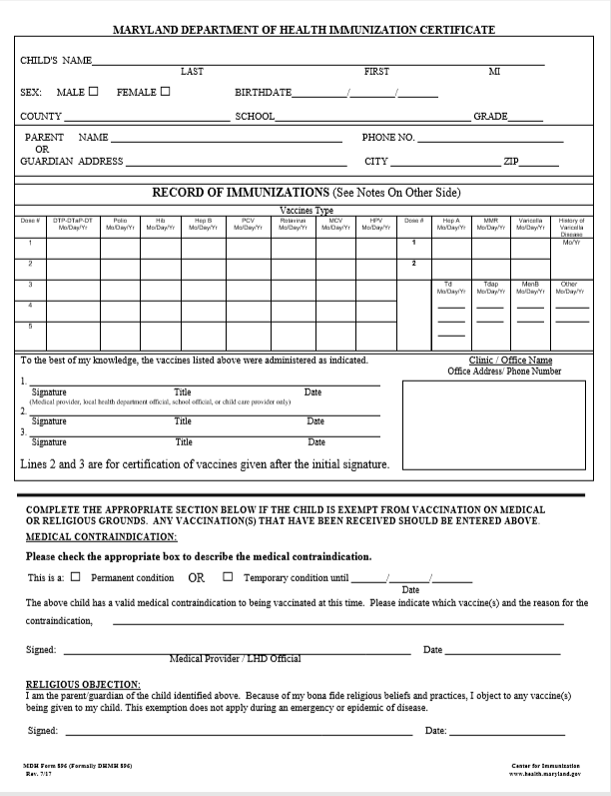
Are there any health problems including physical, psychiatric, or behavioral problems of which we need to be aware? o No
oYes

Are there any medications, dietary restrictions, allergies, or special needs that we need to be aware of to ensure that your child’s camp experience is positive? o No
oYes

List of Known Camper Allergies:

Campers Insurance Information: Primary Medical Insurance Info that I am covered by:
Insurance company: Policy #
Group #

Children’s Health/Sick Admission to Care Policy
Your child must be picked up if they have a fever (100.5), vomiting, or diarrhea occurs anytime dur- ing our care. Berlin Activities Depot must be notified if you take your child to the doctor and they have any communicable disease or illness. Tuition rates still apply during absenteeism.

Parent/ Guardian signature: Date:

24 HOUR RETURN POLICY FOR SICKNESS: Berlin Activities Depot must be notified with a doctor’s note if a child has a communicable disease or illness. Children who have a temperature of 100.5 de- grees or higher, are vomiting, have diarrhea, show symptoms of ringworm, lice, pink eye, rash, se- vere cough, mucus discharge from eyes or nose, or other communicable diseases will not be al-
lowed to attend Berlin Activities Depot. If your child develops a symptom we will notify you, and you will be responsible for picking your child up IMMEDIATELY. If your child has one of the above symp- toms, then your child may return to Berlin Activities Depot 24 hours after all symptoms are gone, or immediately with a doctor’s note showing that the child is not contagious.

Parent/ Guardian signature: Date:

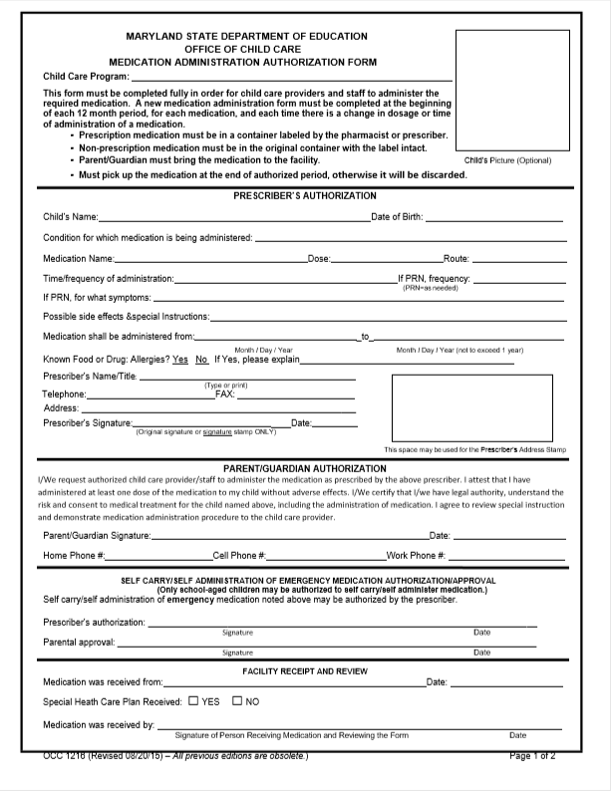

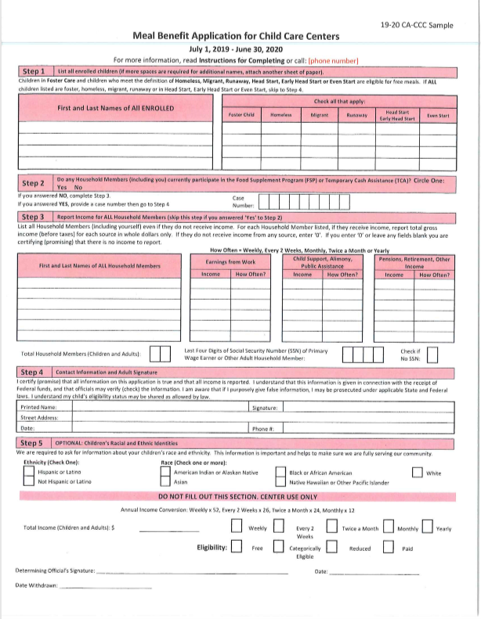
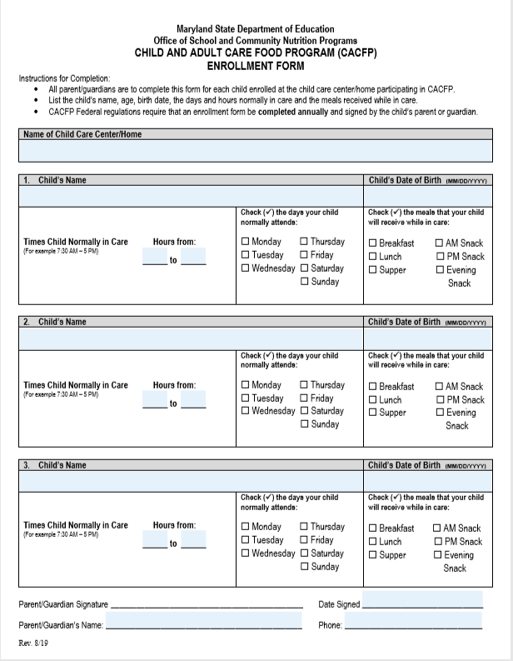

Authorized Pick Up Form

Emergency Phone:
Name:
Emergency Phone:
Name:
ADDITIONAL PICK UP PEOPLE:
Emergency Phone:
Name:
Emergency Phone:
Name:
Please list the names of all who are authorized to pick up your child from camp. Please be advised
that these people will need to show identification before your child will be released to them.

Please note that fobs/cards that are lost for entry into our Depot, will need to be replaced at the camp- ers cost. Security is at the top of priorities of our students. We will buzz in additional people, but we must know in advance.

X I UNDERSTAND THAT LOST FOBS WILL RESULT IN A CHARGE, MY FIRST ONE IS COVERED IN MY SUMMER CAMP ENROLLMENT FEE.

Picture Taking Social Media Permission Slip

I , parent/guardian of , allow Berlin Activities Depot to take pictures of my child during activities of B.A.D Summer Camp. Berlin Activities Depot has permission to use these pictures for marketing and advertising.

Payment Procedures
Credit Card Information
Assigning a form of credit that the center may debit is required. The center at its discretion reserves the right to secure tuition and other debts from the preferred form of Credit identified hereon.

Visa MasterCard Debit checking

Checking account # Routing #
Credit Card # ___________________________________ Zip __________ Expiration Date: 3-digit Code:
X Signature
Date:
Name on Credit Card:

- All students must have a credit card on file. We will automatically charge any outstanding charges that are not paid for the same day, it is the parent’s responsibility to assign their child’s charging parameters and make sure that their tuition and meals and food are paid for.
I understand my card will automatically be charged, I would like to be notified via the following when my card is charged for outstanding charges:
Circle one: PHONE EMAIL

Above the Bar Grub Hub- authorization to charge

X initial- I would like to specify what my child can charge: Circle: Drinks Ice Cream Snacks
I would like my child to purchase other lunch items every-day at camp, if they do not like what is being served per our meal program parameters. EX: Pizza

In the event I opt to bring a lunch for my camper- Lunch Waiver

I , parent / Guardian of will ensure that my child’s
lunch contains only foods that does not need refrigerated or I, the parent/ guardian will provide a cold pack for my child’s lunch that is capable of keeping the temperature of potentially hazardous foods at 45 F or
below. IT IS NOT B.A.D responsibility to ensure that the temperature is sustained throughout the child’s camp day. I will not hold B.A.D. or summer camp or any of its employee’s liable if any accident, injury or death occurs. B.A.D does not provide plastic spoons, forks, or a microwave for campers.
Signature Date

Tuition Due Dates

Payments for B.A.D Summer Camp are due ever Friday prior to the start of the next camp week, or Mon- day by 5 p.m. of the current week, or card on file will be charged. Payments may be made in person at B.A.D by cash, check, or credit card. In addition, payments may also be made by credit card via telephone by calling 410-629-0878 or 410-629-1630. For your convenience, someone is always at the front desk. Credit card authorization forms are also available and once completed your tuition can be directly withdrawn from your accounts each week. This is a convenience that you may use to ensure that you do not incur a late payment fee.
INITIAL that you understand and agree to pay ALL Tuition no later FRIDAY before camp starts on
Monday.
INITIAL that you understand you must pay tuition whether your child comes or not for the duration of the contract
INITIAL that you understand and agree to pay ALL Tuition no later than MONDAYS at 5PM- Your child will not be permitted to attend the field trip Monday if tuition is not paid Friday and your child will not be permitted to attend Tuesday if not paid by Monday.
______INITIAL that you understand that there will be a $35 decline fee will be charged to auto bills that do not go through

Attendance, Deposits, Late Fees, Returned Checks, Personal Items

Once you have signed your tuition agreement you will be responsible for paying the balance of said con-
tract whether your child attends camp or not, even if your child drops out at any time for any reason. Payment is due immediately upon pick-up. You must be packed up and gone by 6:00 p.m. no exceptions!

X Loss Damage and theft of property: we understand and agree that neither the Depot or the officers, directors, agents, or employees shall be responsible for any personal property.
X I understand and agree that there will be extra events at the Depot that will incur extra fees.
X Rules, regulations, and behavior. I understand that B.A.D can terminate agreement due to any and all behavior issues, and require payment.
INITIAL that you understand you must pay tuition whether your child is absent or not.

Berlin Activities Depot Summer Camp 2020 Field Trip Permission Slip
Berlin Activities Depot Summer Camp In case of emergency:
you may contact your child through: Gym: 410-629-0878

Campers Field Trip Rules
- No running where it is not permitted
- No fighting with other group members
- No foul language
- No eating or drinking where it is not permitted
- Please remember sun block for your children (to be applied before entering the gym and extra to be re-
applied through the day). A tube of sunblock must be provided to reapply throughout the day.
- Swimming Field Trips
- All children must be able to swim
- One (1) Lifeguard: 50 swimmers (state regulation)
- Children may pack a lunch (no glass containers)
- Bring money to buy food at the stands/arcade games etc. (Only if your child did not want to take a packed lunch of camp lunch)
- They will need to bring at least one towel and a change of clothes all labeled.
- Note departure time of each field trip, Berlin Activities Depot Camp will not wait for late campers
- Please Note: you can always send your camper with some extra spending money. B.A.D camp can hold your child’s money (if properly labeled) to assure its security.
- *****If your child can not follow the rules, or is a constant threat to the well-being of the rest of the group, he/she will not be permitted to go on any future field trips.

All campers must have a signed permission slip turned in to attend.
Berlin Activities Depot Summer Camp 2020 Field Trip Permission Slip
Child’s Name: Age as of June 5th:________ Age as of August 28th
Each week Berlin Activities Depot Summer Camp participants will take special field trips to offsite locations. In order to ensure the safety and well-being of all campers, we require that this permission slip be completed for all trips that your child may attend during his/her stay at camp. Children without this permission slip on file will not be able to attend our exciting and rewarding field trips which may include, but are not limited to, beach days, water parks, etc.…I, (parent/guardian), give the Berlin Activities Depot/Berlin Activities Depot Summer Camp permission to transport
(child’s name) to and from any and all field trips. This may include-Field trips, mini day trips, and emergencies. Berlin Activities Depot may also transport in the event of any emergency. I will not hold Berlin Activities Depot, Berlin Activities Depot Summer Camp, Twisters INC. or any of its employees liable if accident, injury or death occurs.

Field Trip Continued

Field Trip Permission Swimming Chart (please initial)

Pool/ Water park | Level | At the Beach | Level
 | Up to knees |  | Up to knees
 | Up to Waist |  | Up to Waist
 | Up to Chest |  | Up to Chest
 | Overhead/ Swimmer |  | Overhead/ Swimmer

Berlin Activities Depot Waiver & Release Contract of Payments
In consideration of my membership in Berlin Activities Depot and my participation in Berlin Activities Depot classes, events, and activities, I agree to be bound by each of the following:
- Eligibility: I agree to comply with the rules of Berlin Activities Depot X INITIAL
- Readiness to Participate: I will only participate in those B.A.D classes, events, competitions, and activities for which I believe I am physically and psychologically prepared. Prior to participation, I will have practiced my exercises and will perform only those exercis- es, which I have accomplished to the degree of confidence necessary to assure I can perform them by myself, and without injury.
X INITIAL
- Medical Attention: I hereby give my consent to Berlin Activities Depot to provide, through a medical staff of its choice, customary medical/athletic training attention, transportation, and emergency medical services as warranted in the course of my participation. X INITIAL
- Waiver and Release: I am fully aware of and understand the risks, I allow my child to participate in all activities, specials, and classes including the risk of catastrophic injury, paralysis, and even death, as well as other damages and losses associated with participation in gymnastics activities and events. I will not hold liable Twisters Inc. in any instance. X INITIAL
- I further agree that Berlin Activities Depot and the sponsor of any Berlin Activities Depot events, along with the employees, agents, officers, and directors of these organizations shall not be liable for any losses or damages occurring as a result of my participation in any event, except where such loss or damage is the result of the intentional or reckless conduct of one of the organizations or indi- viduals identified above. X - INITIALS For any athlete who is not yet 18 years old: As legal parent of guardian of this athlete, I
hereby verify by my signature below that I fully understand and accept each of the above conditions for permitting my child to partic- ipate in classes, events, competitions, and activities conducted by Berlin Activities Depot and Twisters Inc.
I agree that by signing the following I am legally liable to pay Berlin Activities Depot, Twisters Inc. the total tuition agreed upon above and do also agree to the terms, rules and regulations that B.A.D has set forth. I also agree to pay my child’s tuition by the Friday prior to the
camp week or by Monday by 5pm, I understand that I will be auto charged through my card on file if my child’s tuition is not paid by Monday at 5 p.m. I also understand that if I should have a check return due to insufficient fund’s I will pay the full tuition with fees before my child can attend. I further understand BAD may exclude my child from activities, of the current week in the event my tuition is not charged. B.A.D reserves the right tol charge me with a $15.00 late fee, and or exclude my child completely without discount or refund if tuition is not paid. I understand that no refunds will be issued and I will be required to pay for weeks specified in this contract even if my child does not attend, because
B.A.D has reserved my child’s spot in the camp for that time period. Spots will not be held without signatures. I understand further that if this account gets turned over to legal counsel, I am liable to pay any and all legal fees that may occur as well as additional late fees.
Membership: Registration must be current. Summer Camp Enrollment includes a field trip t-shirt, fob and or entry to our secure building everyone in camp required to have one. All campers must have a CURRENT membership with Berlin Activities Depot.

Printed Name of Parent/Guardian: Signature of Parent/Guardian: Date:

Deposit and Tuition Worksheet Date signed up: Family Last Name: Days in Attendance: M T W TH F_ Weeks Attendance:

Date Deposit Received in office:

Weeks | Dates | Breakfast Lunch a Snack Ice Cream Allowance | Weekly Depos-  it to be de- ducted from camp tuition | Extended early-7-745  Late Care-515-6 | Family Children  in attendance Write first last name and age | Additional Classes-name | Total each  camper | Total weekly tuition
Early Bird  Summer  Camp-Showell Students | June 8th 2020 | Bfast $  Lunch$ Snacks $  Ice-cream $ | $20.00 per camper weekly | Early  Late
Week 1 | June  17th 2020 | Bfast $  Lunch$ Snacks $ Ice-cream $ | $20.00 per camper weekly | Early Late
Week  2 | June 22nd  2020 | Bfast $  Lunch$ Snacks $ Ice-cream $ | $20.00 per camper  weekly | Early  Late
Week  3 | June 29th  2020 | Bfast $  Lunch$ Snacks $ Ice-cream $ | $20.00 per camper  weekly | Early  Late
Week  4 | July 6th  2020 | Bfast $  Lunch$ Snacks $ Ice-cream $ | $20.00 per camper  weekly | Early Late
Week 5 | July 13th  2020 | Bfast $ Lunch$ Snacks $ Ice-cream $ | $20.00 per camper weekly | Early Late
Week  6 | July 20th  2020 | Bfast $  Lunch$ Snacks $ Ice-cream $ | $20.00 per camper  weekly | Early  Late
Week  7 | July 27th  2020 | Bfast $  Lunch$ Snacks $ Ice-cream $ | $20.00 per camper  weekly | Early Late
Week  8 | August  3rd 2020 | Bfast $  Lunch$ Snacks $ Ice-cream $ | $20.00 per camper  weekly | Early Late
Week  9 | August  10th 2020 | Bfast $  Lunch$ Snacks $ Ice-cream $ | $20.00 per camper  weekly | Early Late
Week  10 | August  17th 2020 | Bfast $  Lunch$ Snacks $ Ice-cream $ | $20.00 per camper  weekly | Early  Late
Week 11 | August  24th 2020 | Bfast $  Lunch$ Snacks $ Ice-cream $ | $20.00 per camper weekly | Early Late
Week 12 | August 30th 2020 | Bfast $  Lunch$ Snacks $ Ice-cream $ | $20.00 per camper weekly | Early Late

***Please note that the first week of Summer Camp will begin on a Wednesday so there will be no field trips for that week***

I agree that by signing the following I am legally liable to pay Berlin Activities Depot, Twisters Inc. the total tuition agreed upon above and do also agree to the terms, rules and, regulations that B.A.D has set forth.

Parent Signature________________________________________ Date______________________

